Heuristic

Evaluation Report



This heuristic evaluation was conducted based on Focusmate’s current website *https://www.focusmate.com/* (accessed March 22, 2019)

Evaluators: Prerna Dave, Shreyansh Banthia & Abhishek Kandoi

Course: Introduction to Human-Computer Interaction Course

Instructor: Sudheendra Hangal Date: March 24, 2021

2

# Executive Summary

As one of the learning components from the Human-Computer Interface coursework, a group of evaluators at Plaksha University conducted a Heuristic Evaluation. A Heuristic Evaluation is a usability testing method that requires no actual users but rather a group of expert evaluators who examines an interface according to its compliance with Jakob Nielsen’s (1995) ten usability principles, or heuristics, as a way to diagnose problems.

This evaluation was conducted by three evaluators on the Focusmate website. It begins with a concise introduction of the website followed by themethodology of producing this report and the heuristics used. In the later part of this report, we have used the heuristic metric and evaluated the platform Focusmate within that metric. As a result, we identi ed positive and negative ndings and have suggested improvements.

During the Heuristic Evaluation, evaluators lled out details including identifying each problem, when and where it occurred, the heuristics it violated, and recommendations before they were compiled into one nal report.

Ultimately, there were some major and many minor usability issues that were identi ed. Some of the major issues include the privacy concern over the video feed which remains to be switched on all the time and can not be switched o even by theuser. In addition to that, while the platform is fairly intuitive in nature with it’s understanding, it lacks consistency with the design, the terminology and the interface as a whole. The toggle buttons of audio and video creates fairly reasonable confusion prompting the user to take a step back. Overall, privacy is a major concern whereas design is an area that can be improved.

The purpose of the evaluation was to provide insight into how the application can improve the usability of the website using industry standards of usability.

3

## About Focusmate

Focusmate is a virtual co-working space that allows members to be part of one-on-one online video sessions with other individuals. These sessions are booked by members to make them focus on tasks by triggering their behavioural pattern in order to achieve a ow state - long stretches of intense focus.

Focusmate integrates 5 behavioral triggers to achieve a ow state:

* Pre-commitment
* Implementation intentions
* Social pressure
* Accountability
* Speci city in task de nition

It’s a community of members who makes them accountable to complete the tasks that a member has set by monitoring their progress during the session and a summary at the end of the session. Focusmate believes thatregular human connection reduces the likelihood that a worker will procrastinate or become distracted.

Focusmate connects members to other professionals who have committed to being accountable for nishing their most important work.

A member chooses a time to work, and Focusmate pairs them with an accountability partner for a live, virtual coworking session that will keep them on task.

4

## Methodology

According to Jakob Nielsen, heuristic evaluation is a systematic inspection where “a small set of evaluators examine the interface and judge its compliance with recognized usability principles”, which are also called “heuristics” - “heuristics” because they are broad rules of thumb and not speci c usability guidelines. Not all principles are usually applicable to an evaluation and they can be added or removed from the process as applicable. In order to produce this report, the three evaluators worked independently with the goal to get familiar with the website and the usability of the platform. Then the evaluators spotted and made the list of problems they faced and post discussion, made a nal compilation of positive and negative ndings along with some recommendations that may help with the improvements.

We evaluated Focusmate according to following ten of Nielsen’s usability heuristics, which are as follows:

H1: Visibility of system status

H2: Match between system and the real world

H3: User control and freedom

H4: Consistency and standards

H5: Error prevention

H6: Recognition rather than recall

H7: Flexibility and e ciency of use

H8: Aesthetic and minimalist design

H9: Help users recognize, diagnose, and recover from errors

H10: Help and documentation

(Nielsen, 1995)

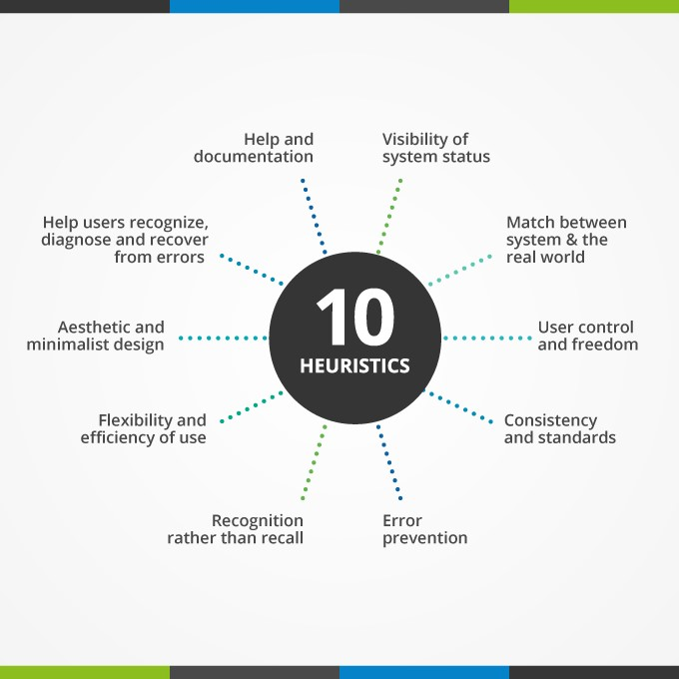

5

There were either the positive or negative ndings in context of above mentioned heuristics. Positive ndings were acknowledged and noted down as it iswhile negative ndings were countered with recommendations.

Findings and Actionable Recommendations #1: Visibility of System Status

Positive Findings:

* While a focusmate session is going on, the title bar continues to show the time left in the session. It’s a good thing to keep the user updated with the working of the system and allowing them to have real time data and time left.



Negative Findings & Possible Improvements:

* Names of the members on the calendar & other personalised attributes of the interface takes time to load when a user is switching pages or views. For some evaluators, it took more than 30 seconds and while they were waiting, there were no system updates provided or any loading/progress bar appeared.

**Recommendation:** It is always good to keep a user informed on the progress of the backend work going on. A progress bar like below is always helpful.

6

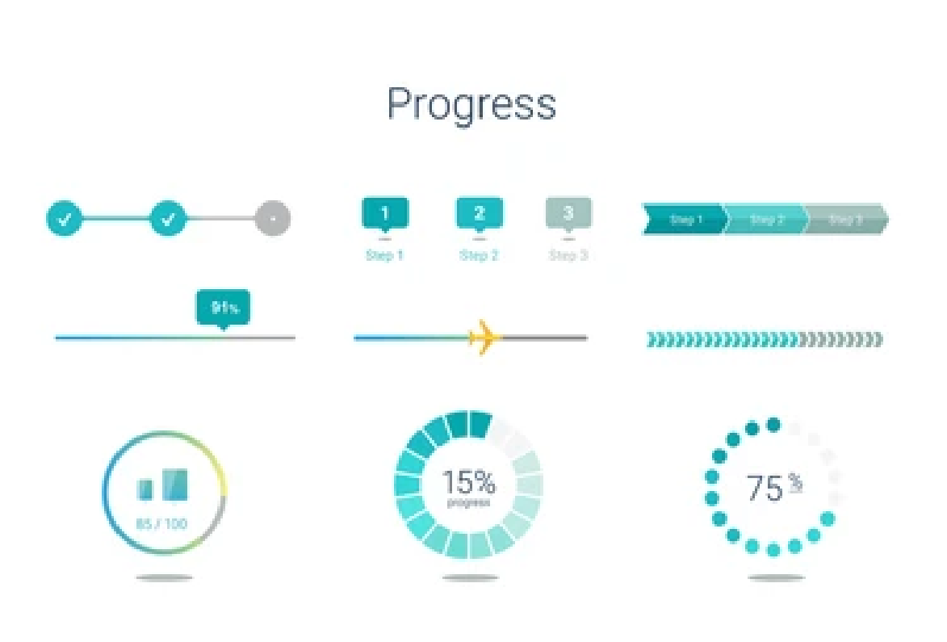

* Title of pages seems to be too long and are irrelevantwith the page description. The title is "stop procrastinating, boost productivity & get focused on work: focusmate". This is too long a title for a tab in a browser and is not visible if multiple tabs are on. The titles do not indicate if the user is on the dashboard or any other page unless the user is in a session.



**Recommendation:** Usage of small, relevant titles is helpful for users to identify their position in the sitemap.

* When a user has no sessions scheduled or none in the past, clicking on upcoming sessions or the past week tab shows just a blank page.

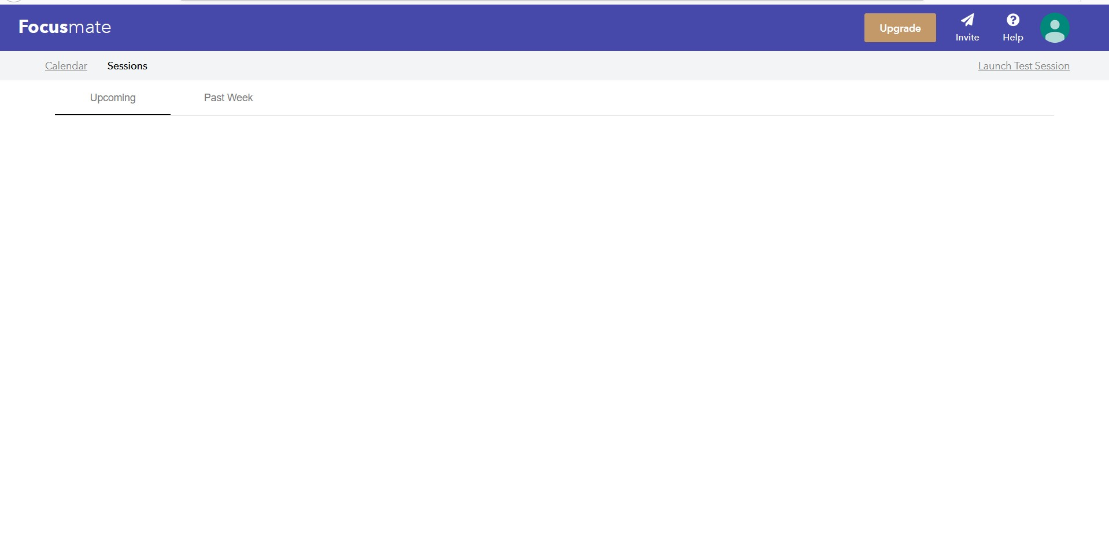

**Recommendation:** It could say “no sessions here”. A blank page could at times make the user doubt it’s internet connection and show incompleteness.

7

* The app does not give any noti cations when a Focusmate sessions starts or is about to start and this may lead to a user missing a session

**Recommendation:** A noti cation or pop-up could help a user to be aware of upcoming events.

* The app does not notify you if your session-mate is facing internet issues and takes time to notify the user if their internet is having technical issues.

**Recommendation:** A noti cation or pop-up could help a user to be aware of this glitch so they can rectify if needed.

## #2: Match between system and the real world

Positive Findings:

* Much of the functionality is fairly intuitive & a user can straightaway start using the platform with minimal e orts.

Negative Findings & Possible Improvements:

* Turning o the camera for the other person does not really turn the camera o . You can see the green light beside your webcam always and that means that it is taking video input. No other video conferencing app does that and it is a serious privacy concern too.

**Recommendation:** Rectify the issue and allow the user to toggle between the camera settings as per their requirements. Continuous video feed is breach of privacyto an individual.

* The network tab while in session uses the term "packet loss" which is a really technical term and is not understandable to a layman.

8

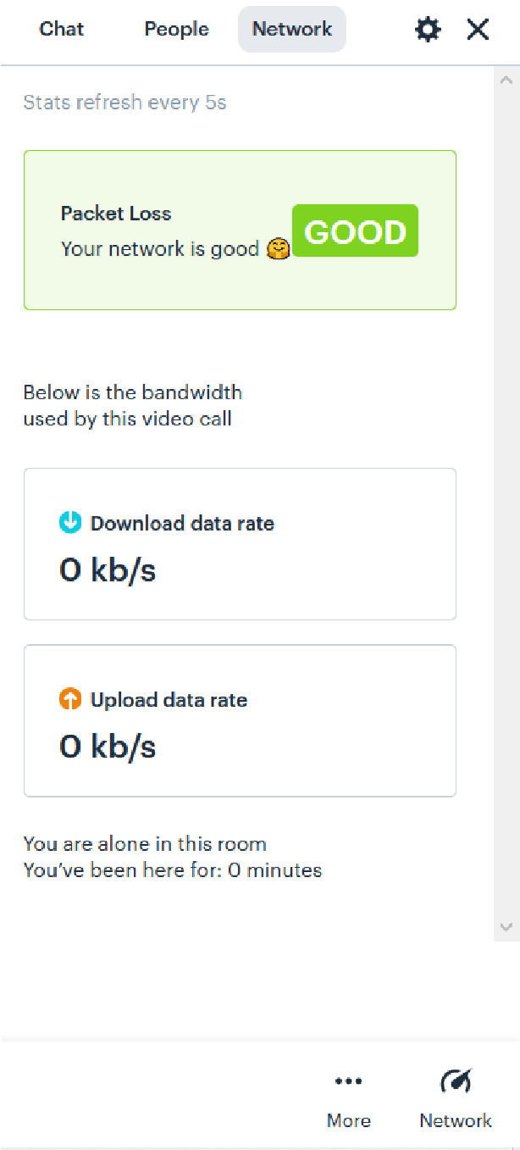

**Recommendation:** The platform should try to use simple relevant words that are understandable to its audience intuitively.

* Active speaker prominence is a feature which is never seen before and could be written in a more intuitive language. Moreover, it is very unclear what toggling this button does since it made no di erence in our test sessions.

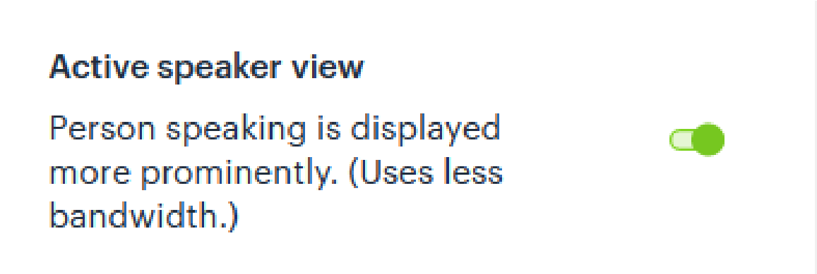

**Recommendation:** Transparency and simpler terminology will help users feel more comfortable and part of the system.

* The buttons to toggle audio and video in the session are unintuitive and not in line with what users are used to. One of the buttons below represents videoturned o and one represented video turned on and it is very hard to distinguish between those.

9



Likewise the audio toggle button is confusing as well.

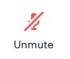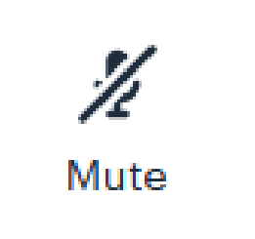

**Recommendation:** The platform might want to switch more understandable buttons by removing the slanted line and making the camera icon more prominent while the video is on. One suggestion other than the general toggleable icons used by Zoom & Hangouts might be as follows:

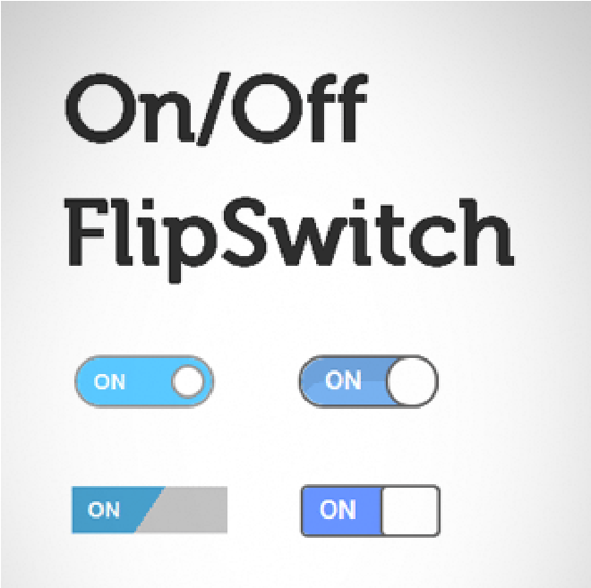

* Invite button on a site is generally for inviting people to the platform, this one is to send an invite link to a session. While that’s not really a huge problem, it is slightly confusing and branching out from other platforms.

10

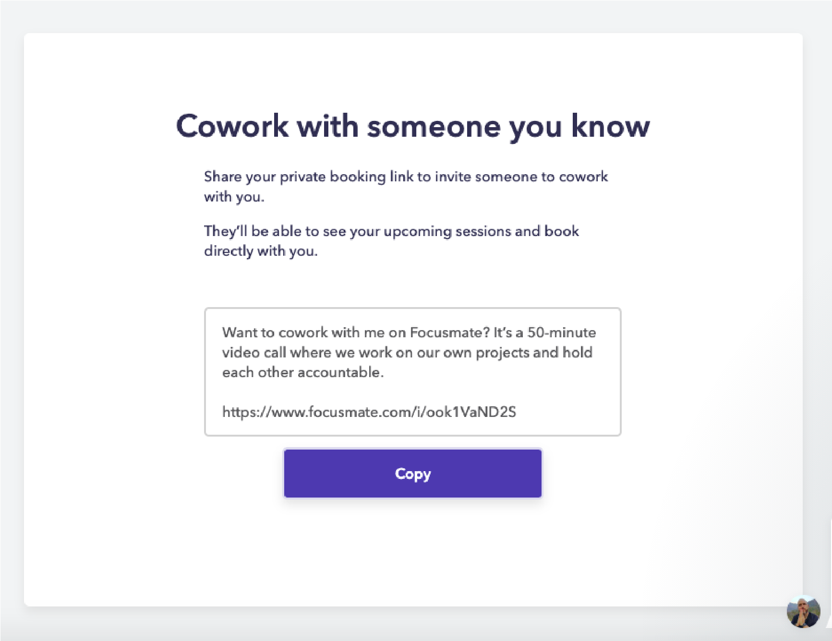

**Recommendation:** The platform may carry on with this but could also try to make it clearer by specifying “Invite for the session”

* View pro le button is really small and is hard torecognize at rst. It was often mis-clicked by the evaluators as well and ended up clicking on a new session rather than viewing pro le.



**Recommendation:** Enlarging the pro le button or increasing the area in which anywhere we click should open the pro le.

11

## #3: User control and freedom

Positive Findings:

* The platform allows the user to set up their own timings for the session allowing exibility.
* Users can as well set up recurring sessions allowing them to work at their own pace and their own stretch.

12

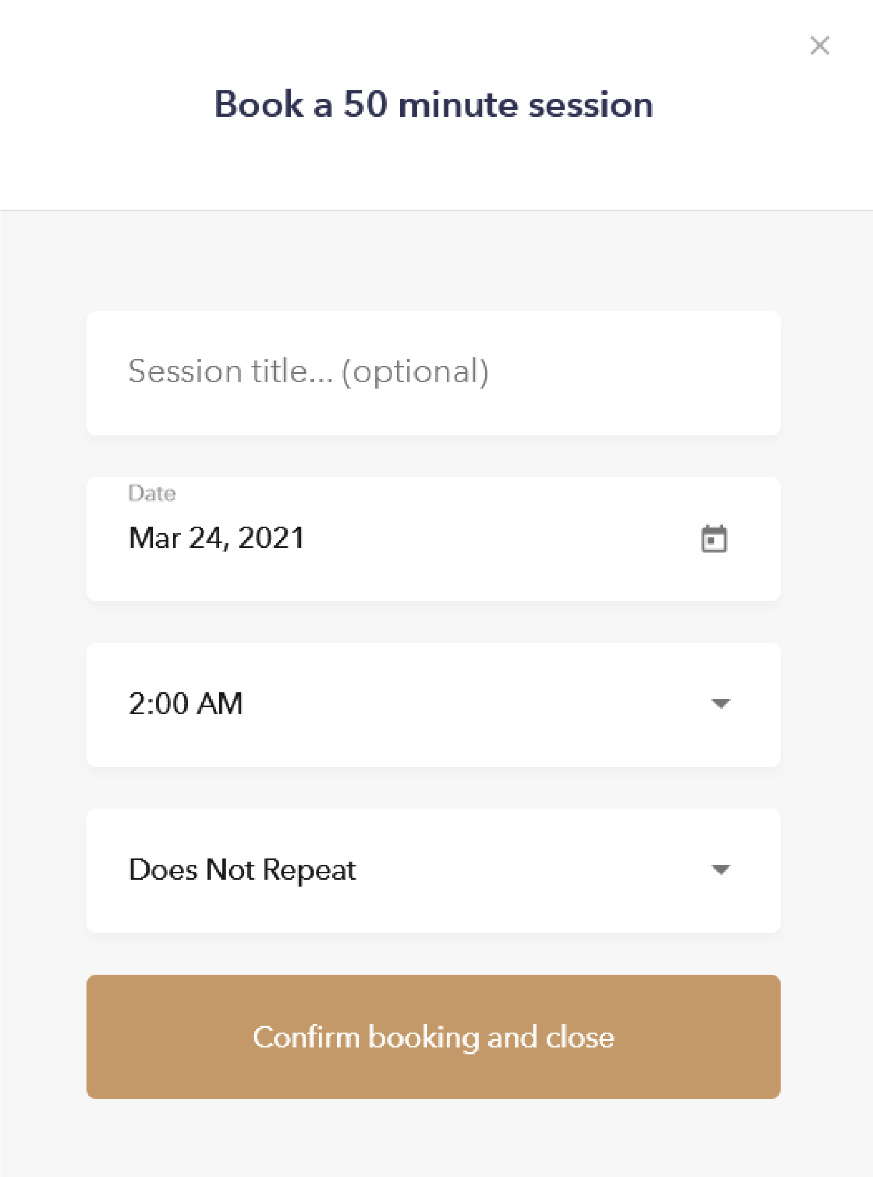

* Users can select gender preferences when setting up a session. This lets users select their comfort areas.
* Users have the option to cancel & edit a session after booking; clearly labeled cancel buttons in the session card and the editing window allows this process to be carried out e ectively and e ciently.

13

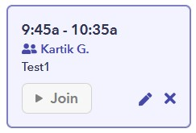

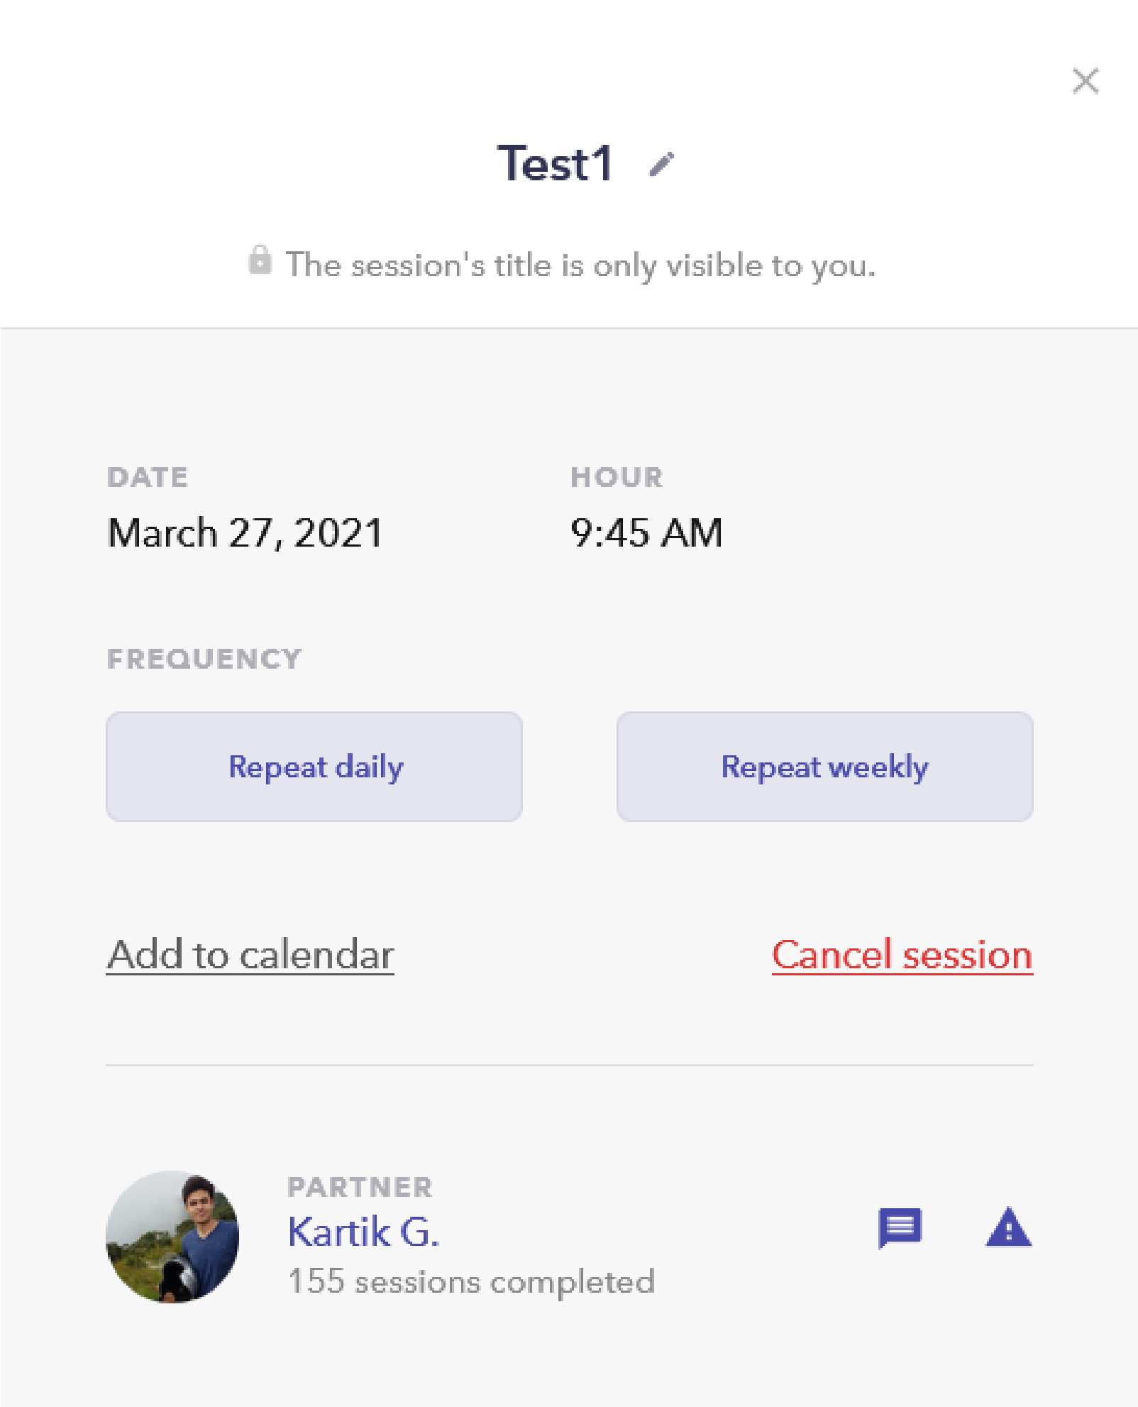

14

* A con rm booking button exists before booking a session asking for a con rmation allowing the user to rethink on the event and make an informed decision.

Negative Findings & Possible Improvements:

* None of the settings on the main page are sticky - they don’t stick. They are not remembered from the last use and need to be set on every use.

**Recommendation:** Allow users to save a setting so as to save time and e ort.

* The person that is being shown on the screen as being available at a given time is often not the person who is assigned to you. It creates an illusion of a control on booking the session rather than actual control. It shows lack of transparency.

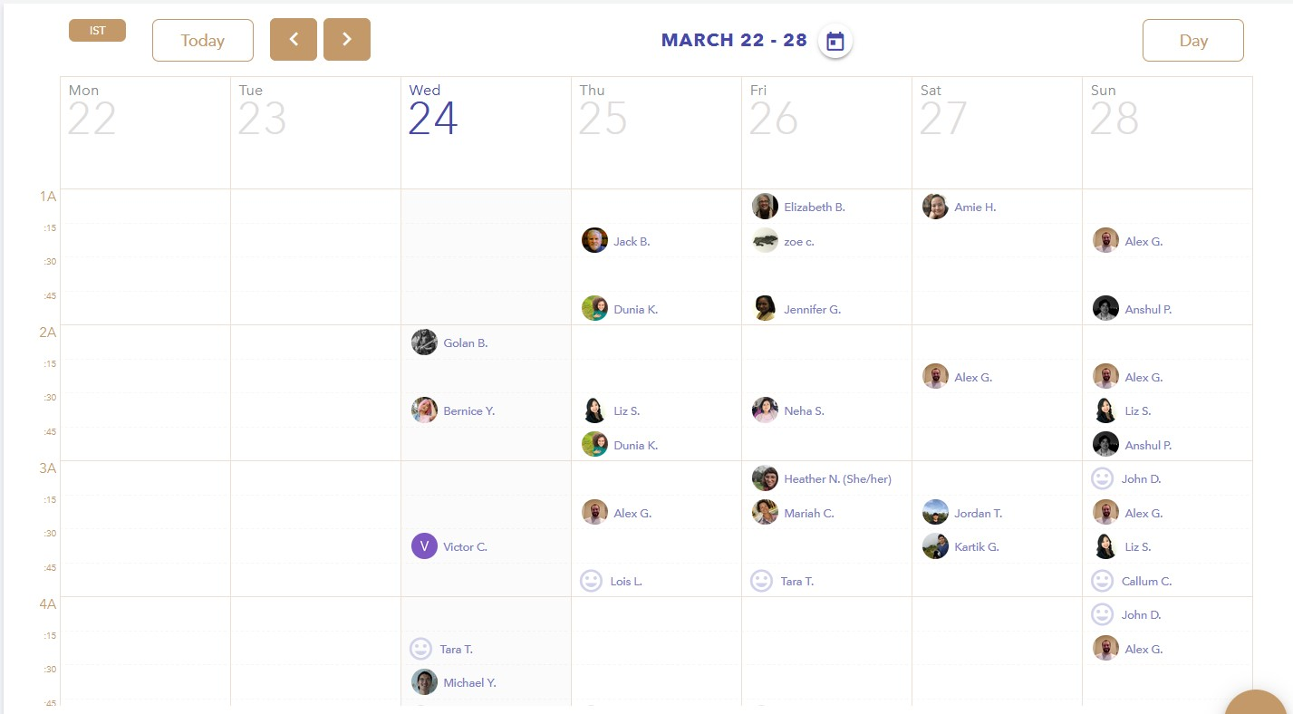

**Recommendation:** Be honest with the user and let them know that there may be a chance that the same user won’t be available. The platform should not breach the trust.

## #4: Consistency and standards

Positive Findings:

* Overall, a consistent naming and terminology has been used allowing users to be aware of the content of the platform.

15

Negative Findings & Possible Improvements:

* On the contact us page, the arrow pointing to the chat button is misplaced for some scroll positions

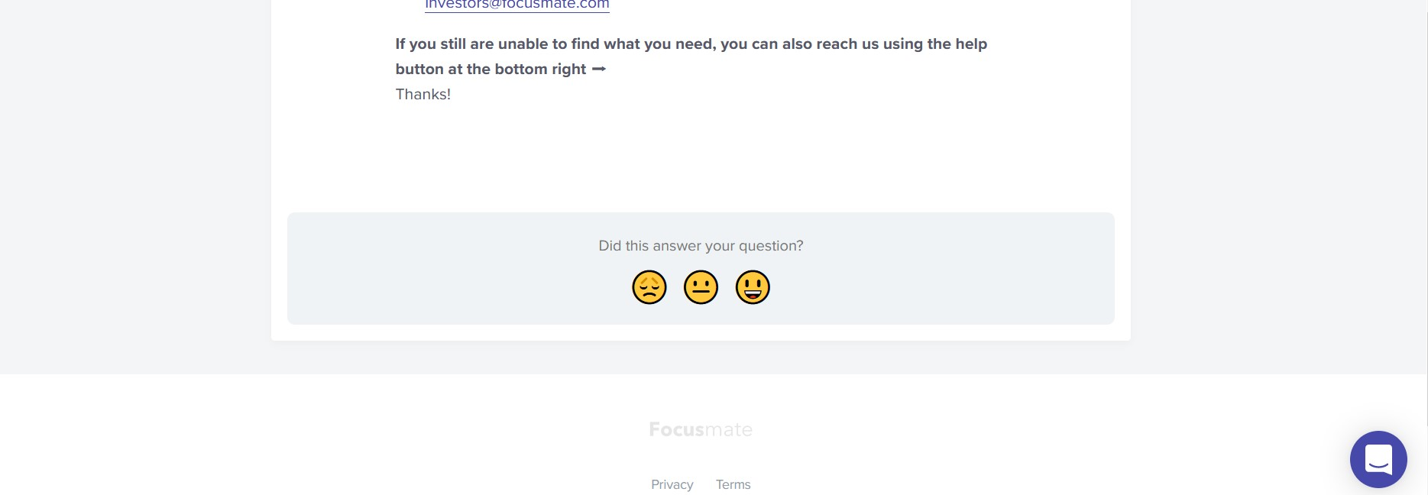

* The side button (burger icon) already has the drawer popped when the home screen is loaded. Clicking it hides the menu & that feels counter-intuitive.

Recommendation: Have the menu closed when a user enters the dashboard. Other possibilities of making the menu popup more intuitive need to be explored.

* Users can’t see the person’s pro le during the session while similar buttons do so outside the session.

Recommendation: Allow the pro le button to be clickable while in a Focusmate session

* Sometimes text & buttons look similar especially in the chat window. "Save Chat" & "encrypted" look similar except that "save chat" is a button. Similarly, the launch test session button is too small and looks like plain text.



Recommendation: Make sure that buttons are distinguished from plain-text or hyperlinked texts.

Hyperlinked tests are generally used to direct to di erent pages. At only a few places, the app is using texts to perform functions like saving chats & launching test sessions which is inconsistent.

**Overall Recommendation:**Consistency is key to a good user experience. Hence, the recommendation is to rectify these issues and make sure there is consistency maintained throughout and not have counter intuitive setup. Also, there is a need to maintain the highest standards and adhere to them.

16

## #5: Error prevention

Positive Findings:

* Users are noti ed when their own network is glitchy or if they get disconnected.

Negative Findings & Possible Improvements:

* No noti cations are given to users when their session partner’s network has any issues.

**Recommendation:** The user should be provided with accurate information about the partner’s network. It is needed so one can take a decision whether or not to continue the session if the glitch continues.

* When verifying a new user, an error in entering information by the user will cause the user to be blocked for a while. However, the “issues” section provides no clari cation on this particular error.

Moreover, there is no clarity on how long the user would be blocked for.

**Recommendation:** The user should be provided with information as to when the block will be removed.

This is bene cial as to plan the calendar and schedule ahead.

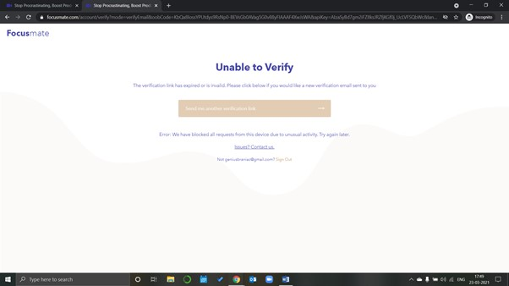

17

## #6: Recognition rather than recall

Positive Findings:

* Most features rely on recognition & intuitive use. For example, the calendar interface is mostly built like general calendar interfaces like Google Calendar allowing users to feel familiar with the platform.
* The evaluators were able to use almost the entire application with ease in the rst go without external use.

Negative Findings & Possible Improvements:

* How to schedule a session with a particular person is a feature that relies more on recall but could become intuitive after a some time

**Recommendation:** The invite button can help you send an invitation to a friend and schedule a session. The name and/or position of that button along with the icon can be changed to something more appropriate & intuitive.

* While in a session, the space-bar button brings in the option to send emojis and reactions to the other person. This feature is not mentioned anywhere and only power users might be aware of it. **Recommendation:** It would be good to have a small buttonto open the emojis menu at the bottom beside other meeting controls.

## #7: Flexibility and e ciency of use

Positive Findings:

* Customization is available for weekly/daily view of sessions scheduled & people available for sessions.



Negative Findings & Possible Improvements:

* The weekly & daily views are only vertically scrollable. That might cause new users to forget to scroll down to see their sessions. It is also a hassle & since sessions are spaced out there should be a way to

18

see the calendar in one view with all daily/weekly sessions. It would be good to have other layouts available based on user preference.

**Recommendation:** Explore other variants of representing sessions blocked on the calendar that a user can select. One of them would be to list daily/weeklysessions instead of spacing them out based on theirtime slots.

## #8: Aesthetic and minimalist design

Positive Findings:

* The application does a superb job at this. The UI is very near and not cluttered on any page.

Negative Findings & Possible Improvements:

* While in session, hovering over the meeting controls causes the colors of the buttons to change. While the mute & video buttons change to a peach color, the chat & share buttons change to blue & green respectively. This can be somewhat confusing and also looks incoherent. For the chat & share icons, these colors do not match with the palette of the website and neither do they carry any special meaning. As mentioned before, with the mute and video buttons, the red color does not help with understanding whether the video is turned on or o .

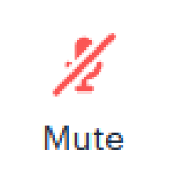

**Recommendation:** Have coherent and intuitive colors for active/hovered over icons. It may add to aesthetics and design.

## #9: Help users recognize, diagnose, and recover from errors

Positive Findings:

* Since the application is fairly simple and doesn't have too many bells and whistles, there aren't too many touchpoints where errors come up for the application's usual users. In the limited scenarios where errors do come up, the application developers seem to be taking low hanging fruits. For

19

example, during a session, if your internet connection goes then, we get to see the following error message on our screens.

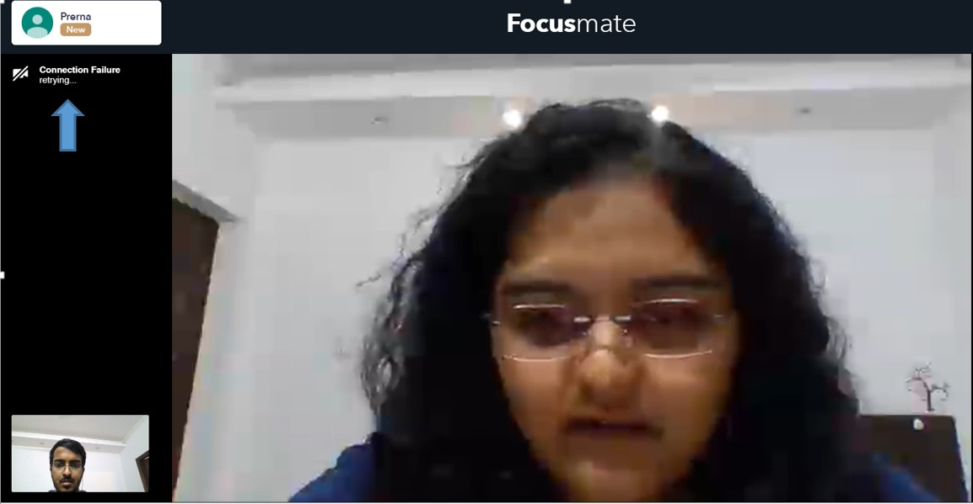

Negative Findings & Possible Improvements:

* During a session, if a person gets disconnected, then upon reconnection, all their in-call settings like being on mute, or keep the camera o etc., get reverted to default settings. Since this happens without the user being informed, it’s an issue that impedes the user’s recovery from errors. Example below -

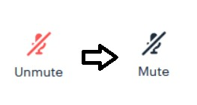

**Recommendation:** It will be good to have sticky settings for users while in a Focusmate session.

* While we get a generic indicator when we are having internet connection issues, we get no noti cation or indication when the other person has internet issues. This often leads to the user being confused if it’s their internet connection that is acting up.

**Recommendation:** Provide real time data on the partner’s internet connection as well. It will help a user to know if the partner is equipped with internet connection and is engaged.

20

* There are still some errors (seem like the rarer ones) where the user is still left with unclear messages and no straightforward instructions to recover from these errors. Example provided below -

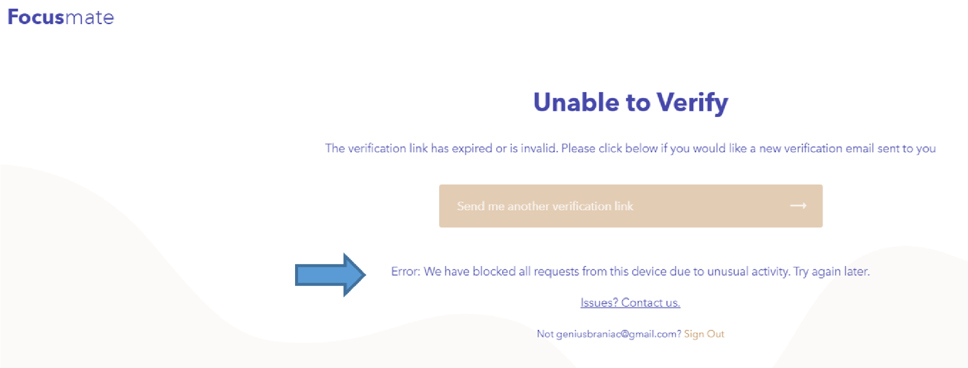

**Recommendation:** Even if rare, have provisions to address the issue.

## #10: Help and documentation

Positive Findings:

* The Focusmate application is fairly new, and the company behind it is early-stage, so they seem to be operating with a small support team and depend heavilyon interactions happening on their Facebook page to often resolve most queries of their users as well as to provide support. Given these constraints, they have fairly well-documented FAQ & Help sections where the information retrieval process has been given thought to and have a simple design. Some examples of this can be seen below

-

21

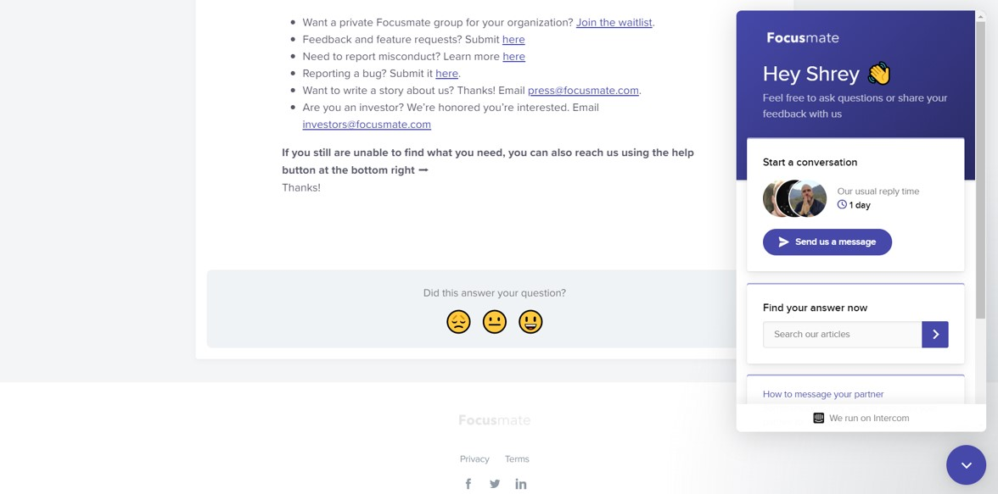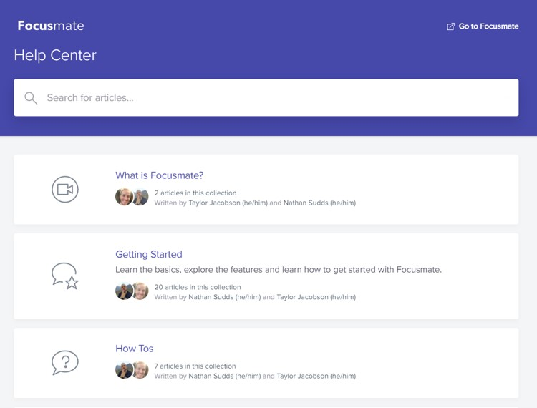

22

* They also have a few other good features in their platform like - Having a quick 3-minute video to educate rst-time users on how to use the platform and quickly get started, provision of the functionality to do a test session at any point in time to see if their PC and internet connection is ready to start a real session etc.
* Another interesting observation is that the important guidelines with regards to a session are always available to view on the main screen and are sharp while being actionable. Examples below -

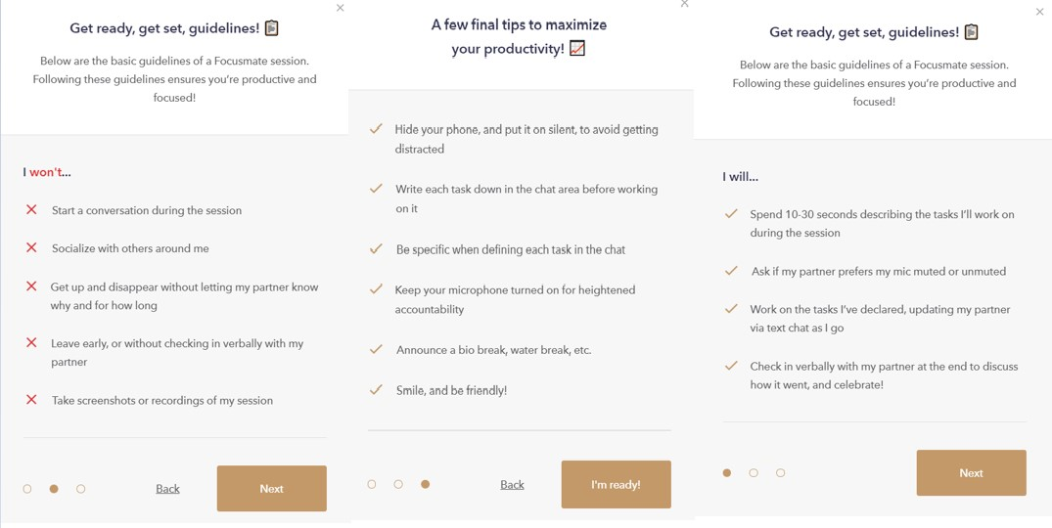

Negative Findings & Possible Improvements:

* The platform has a functionality to join groups but the information around the same is hard to reach and this is the only major shortcoming that we could nd in this section. Example below -

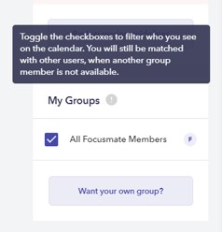

23

**Recommendation:** Information on how to join groups and related topics can be provided on the main page where the groups section is present.

References

<https://xyuliu.com/Heuristic-Evaluation>

[https://static1.squarespace.com/static/54d7d226e4b0340f2fb9246e/t/54e015f1e4b033d521c5ac4b/14239 71825318/HeurisitcEvaluation_PaceLibrary.pdf](https://static1.squarespace.com/static/54d7d226e4b0340f2fb9246e/t/54e015f1e4b033d521c5ac4b/1423971825318/HeurisitcEvaluation_PaceLibrary.pdf)